Basic Design and Technology
BECE 2019 — Paper 1 (Objective)
1. The plan of a cylinder is a
A. circle.
B. rectangle.
C. square.
D. triangle.
2. The first stage of the design process is
A. brief.
B. evaluation.
C. situation.
D. specification.
Figure 1 shows the pictorial view of a block. Use it to answer questions 3 and 4.
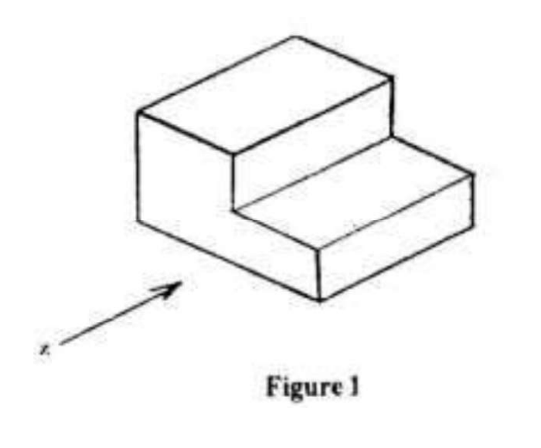
3. Which of the following represents the front view in the direction of arrow Z?
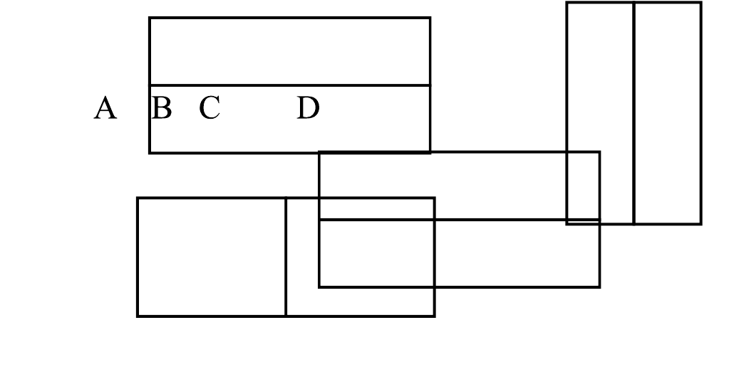
4. Which of the following represents the right end elevation?
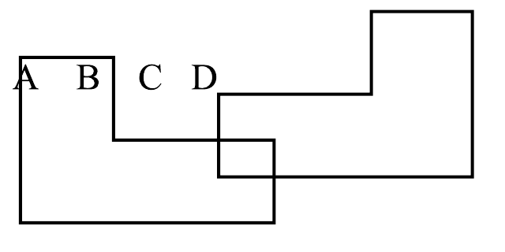
5. In the design process, the selected idea is developed in order to
A. determine the cost.
B. evaluate final product.
C. improve upon it.
D. reduce its beauty.
6. The most suitable pencil for drawing construction lines is
A. B.
B. HB.
C. 2B.
D. 2H.
7. A common method of cooking used for most Ghanaian staple foods is
A. steaming.
B. boiling.
C. frying.
D. stewing.
8. A seam that is often used for outer garment is
A. plain seam.
B. French seam.
C. Machine felled seam.
D. Overlaid seam.
9. When setting a table, the first course cutlery should be placed
A. at the top edge of the dinner plate.
B. on the dinner plate.
C. near the dinner plate.
D. further away from the dinner plate.
10. Stranded cotton thread is used for
A. decorative stitches.
B. neatening seams.
C. joining seams.
D. temporary stitches.
11. Red, Orange and violet are
A. warm colours.
B. cool colours.
C. opposite colours.
D. neutral colours.
12. The inscription BB on a pencil indicates that, it
A. is hard.
B. is soft.
C. breaks easily.
D. sharpens well.
13. A circle is
A. a form.
B. a principle of design.
C. a sphere.
D. an element of design.
14. The colour violet symbolizes
A. wealth.
B. peace.
C. aggression.
D. royalty.
15. The primary colours are
A. red, violet, yellow.
B. green, yellow, red.
C. red, yellow, blue.
D. violet, yellow, green.
16. The most important nutrients found in vegetables are vitamins and
A. carbohydrates.
B. proteins.
C. minerals.
D. fats.
17. In frying meat, heat is transferred by means of
A. conduction.
B. convection.
C. conduction and radiation.
D. radiation and convection.
18. Elements of design in nature include
A. lines, shape and dot.
B. shape, dot and balance.
C. line, rhythm and texture.
D. texture, balance and rhythm.
19. An adolescent whose diet is deficient in iron is likely to suffer from
A. rickets.
B. goiter.
C. scurvy.
D. anaemia.
20. Wounds and fractures can heal quickly if one takes in adequate amount of
A. starchy roots and plantain.
B. fruits and vegetables.
C. animal products.
D. legumes and pulses.
21. A stitch that is worked from right to left on the right side of an article is
A. overcasting.
B. oversewing.
C. hemming stitch.
D. slip stitch.
22. Which of the following elements of design is likely to be seen on whole baked rock buns?
A. Lines, colour and dot.
B. Shape, texture and dot.
C. Texture, shape and lines.
D. Colour, lines and dot.
23. Incorrect threading of a sewing machine will cause
A. puckering of seams.
B. missing stitches.
C. thread breaking.
D. loose stitches forming.
24. Suitable inexpensive fabric for making bag is
A. poplin.
B. denim.
C. damask.
D. calico.
25. The cause of spoilage in dried beans is
A. weevil.
B. bugs.
C. yeast activities.
D. enzymes action.
26. The rubbing-in method is used in the preparation of
A. queen cakes.
B. fish turnovers.
C. banana fritters.
D. sweet pancakes.
27. A suitable leavening agent that can be used in the preparation of banana cake is
A. palm wine.
B. cream of tartar.
C. baking powder.
D. bicarbonate of soda.
28. Heat is transferred by conduction and convection when food is cooked by
A. steaming.
B. frying.
C. grilling.
D. baking.
29. In Ghana, a popular method for preserving most food commodities at home is
A. drying.
B. salting.
C. smoking.
D. bottling.
30. The main use of fat in cake making is to
A. enhance appearance.
B. increase volume.
C. improve keeping quality.
D. improve flavour.

Answer Key
1. A circle  2. C situation  3. C (see diagram, option C)  4. A (see diagram, option A)  5. C improve upon it  6. D 2H  7. B boiling  8. A plain seam  9. A at the top edge of the dinner plate  10. A decorative stitches  11. A warm colours  12. B is soft  13. D an element of design  14. D royalty  15. C red, yellow, blue | 16. C minerals  17. A conduction  18. A lines, shape and dot  19. D anaemia  20. B fruits and vegetables  21. B oversewing  22. B Shape, texture and dot  23. D loose stitches forming  24. D calico  25. A weevil  26. A queen cakes  27. D bicarbonate of soda  28. A steaming  29. A drying  30. B increase volume

